

Dr. D. Y. Patil Pratishthan's College of Engineering
Salokhenagar, Kolhapur
2024-2025
DEPARTMENT OF COMPUTER SCIENCE & ENGINEERING


A
PROJECT REPORT ON
“FAKE NEWS DETECTION”
Submitted by:

Name | Roll No.
Dhanashri Ekanath Khondre | 29
Sakshi Sudhir Mohite | 42
Aditi Rajiv Patil | 47
Bhumika Sandip Patil | 48

Under the Guidance of
Prof. Supriya Laykar
(Associate Professor)

SHIVAJI UNIVERSITY, KOLHAPUR

Dr. D. Y. Patil Pratishthan's College of Engineering Salokhenagar, Kolhapur
2024-2025
DEPARTMENT OF COMPUTER SCIENCE & ENGINEERING

CERTIFICATE
Certified that the Project topic entitled “Fake News Detection” a Bonafede work carried out by ……………………………………… in partial fulfilment for the award of Degree of Bachelor of Engineering in 6th Semester of the SHIVAJI UNIVERSITY, KOLHAPUR during the year 2024-2025. It is certified that all corrections/ suggestions indicated for Internal Assessment have been incorporated in the report deposited in the Department Library. The Project report has been approved as it satisfies the Academic requirement in respect of Project work prescribed for BACHELOR OF ENGINEERING DEGREE.

Prof. Supriya Laykar Prof. Rohit Raut Mr. Suresh Mane
(Guide) (H.O.D) (Principal)
EXAMINERS SIGNATURE WITH DATE
1.
2.

CONTENTS
- INTRODUCTION
  - Introduction…………………………………………………

- LITERATURE SURVEY
  - Literature Survey……………………………………………

- PROPOSED SYSTEM
  - Proposed System……………………………………………

- SYSTEM ANALYSIS
  - Problem Statement…………………………………………..
  - System Requirements……………………………………….
    - Software Requirements……..……………………………
    - Hardware Requirements…………………………………

- SYSTEM DESIGN
  - System Implementation………………………………………
  - Snapshots……………………………………………………..

- CONCLUSION

- REFERENCES

ABSTRACT
The Fake News Prediction System is designed to detect misleading news articles using Machine Learning (ML) and Natural Language Processing (NLP) techniques. The model classifies news as real or fake based on textual analysis. The project involves data pre-processing, feature extraction using TF-IDF, and classification using Logistic Regression. This system provides an automated and efficient method to combat misinformation and promote factual accuracy in digital media.
With the increasing influence of social media and online platforms, the spread of fake news has become a critical problem. Traditional fact-checking methods are slow and manual, requiring an automated approach for real-time analysis. The proposed system processes news articles, extracts meaningful features, and applies machine learning techniques to determine their authenticity.
This report details the development lifecycle, including data pre-processing, feature engineering, model training, evaluation, and future enhancements. The findings indicate that machine learning models can effectively classify fake news with high accuracy, making them a viable solution for mitigating misinformation online.

INTRODUCTION
These days fake news is creating different issues from sarcastic articles to a fabricated news and plan government propaganda in some outlets. Fake news and lack of trust in the media are growing problems with huge ramifications in our society. Obviously, a purposely misleading story is “fake news” but lately blathering social medias discourse is changing its definition. Some of them now use the term to dismiss the facts counter to their preferred viewpoints.
The importance of disinformation within American political discourse was the subject of weighty attention, particularly following the American president election. The term 'fake news' became common parlance for the issue, particularly to describe factually incorrect and misleading articles published mostly for the purpose of making money through page views. In this paper, it is seemed to produce a model that can accurately predict the likelihood that a given article is fake news. Facebook has been at the epicentre of much critique following media attention. They have already implemented a feature to flag fake news on the site when a user sees it they have also said publicly they are working on to distinguish these articles in an automated way. Certainly, it is not an easy task. A given algorithm must be politically unbiased – since fake news exists on both ends of the spectrum – and also give equal balance to legitimate news sources on either end of the spectrum. In addition, the question of legitimacy is a difficult one. However, in order to solve this problem, it is necessary to have an understanding on what Fake News.

Importance of Fake News Detection:
- Prevents misinformation from misleading people.
- Helps fact-checking agencies and media organizations verify news authenticity.
- Reduces the negative impact on public trust and democracy.
- Supports government and policymakers in combating disinformation campaigns.

Objectives:
- To develop a machine learning-based fake news detection system.
- To preprocess textual data using NLP techniques (tokenization, stopword removal, stemming).
- To extract features using TF-IDF vectorization for model training.
- To train and evaluate a classification model (Logistic Regression, Random Forest, etc.).
- To compare different models and select the most accurate and efficient algorithm.
- To provide real-time predictions for fake news classification.
LITERATURE SURVEY

Overview :
The problem of fake news detection has gained significant attention over the past few years. Several systems and models have been proposed, each attempting to solve the problem using a different approach.

2.1 Existing Approaches :

Rule-Based Systems

These systems rely on predefined rules and patterns to classify text as fake or genuine. Although easy to implement, they lack the flexibility and adaptability to cope with the evolving nature of fake content.

Traditional Machine Learning Models

Support Vector Machines (SVM), Naive Bayes, and Logistic Regression are commonly used for fake news detection. These models rely on manually engineered features extracted using NLP techniques.

Deep Learning Models
Advanced architectures like Convolutional Neural Networks (CNNs) and Recurrent Neural Networks (RNNs), particularly Long Short-Term Memory (LSTM), have been employed to improve accuracy by learning hierarchical representations of text.
Hybrid approaches
Combining traditional ML models with rule-based systems and deep learning has shown improved results in terms of accuracy and robustness. These models aim to utilize the strengths of different techniques.

2.2 Limitations of Existing Systems
- Most systems are limited to English-language datasets.
- Difficulty in handling sarcasm, satire, and ambiguous text.
- High dependency on labelled datasets.
- Inability to adapt to new forms of fake content, such as AI-generated news.
PROPOSED SYSTEM

Methodology:
- Data Collection: Data collection is the foundational step where the dataset is obtained from reliable sources. For fake news detection, we sourced our dataset from Kaggle, open data repositories, and authenticated news websites. The dataset includes labelled instances of both real and fake news articles, making it suitable for supervised machine learning tasks.
- Text Pre-processing: Pre-processing involves cleaning and transforming raw text into a format suitable for modelling. Key steps include:
  - Tokenization: Splitting a text into words or tokens. For example, "Fake news spreads fast" becomes ["Fake", "news", "spreads", "fast"].
  - Stopword Removal: Commonly used words like "the", "is", "and" that do not add significant meaning are removed.
  - Stemming: Reducing words to their root form, e.g., "running", "runner", and "ran" all become "run". This helps standardize vocabulary.
- Feature Extraction: Machine learning models require numerical input, hence we transform text into numbers using TF-IDF:
  - Term Frequency (TF): Measures how frequently a term occurs in a document.
  - Inverse Document Frequency (IDF): Measures how important a term is, reducing the weight of commonly occurring words.
  - TF-IDF Score = TF * IDF, which helps to retain meaningful words while downplaying frequently used words.
- Machine Learning Models: Several algorithms can be applied for classification:
  - Logistic Regression: A simple yet effective linear model for binary classification. It calculates probabilities and classifies the news accordingly.
  - Random Forest: An ensemble model that builds multiple decision trees and combines their outputs. It's robust and handles overfitting well.
  - Naïve Bayes: Based on Bayes Theorem, it assumes feature independence and works well with text classification.
  - Support Vector Machines (SVM): Maximizes the margin between data points and works effectively in high-dimensional space.

- Evaluation Metrics: To measure model effectiveness, we use:
  - Accuracy: Percentage of correctly classified news articles.
  - Precision: True positives / (true positives + false positives). Indicates reliability of positive predictions.
  - Recall: True positives / (true positives + false negatives). Indicates how well the model captures actual positives.
  - F1-score: Harmonic mean of precision and recall, providing a balanced measure.
Data Flow Diagram:
DFD level 0 –


DFD level 1 –
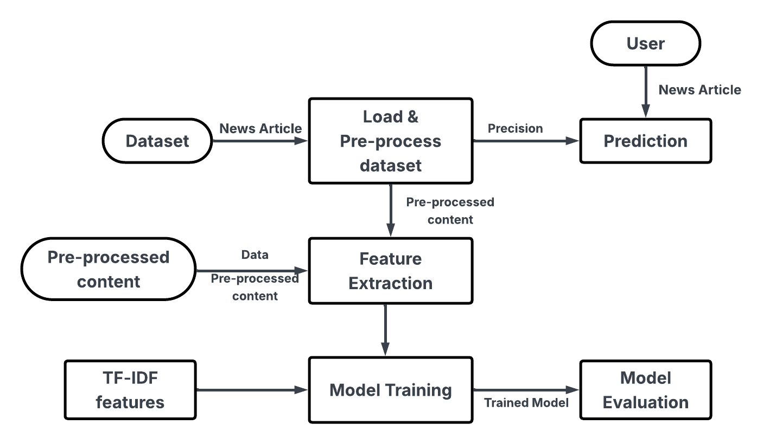

Algorithm :
- User uploads a dataset of news articles (real + fake).
- Text is cleaned: remove punctuation, lowercase conversion, stopwords removal, and stemming.
- Data split into training and testing (usually 80:20).
- TF-IDF Vectorizer transforms text into numerical format for machine learning.
- Logistic Regression model is trained on the data.
- Model predicts whether test articles are real or fake.
- Accuracy score and confusion matrix evaluate the model's performance.

Flowchart:
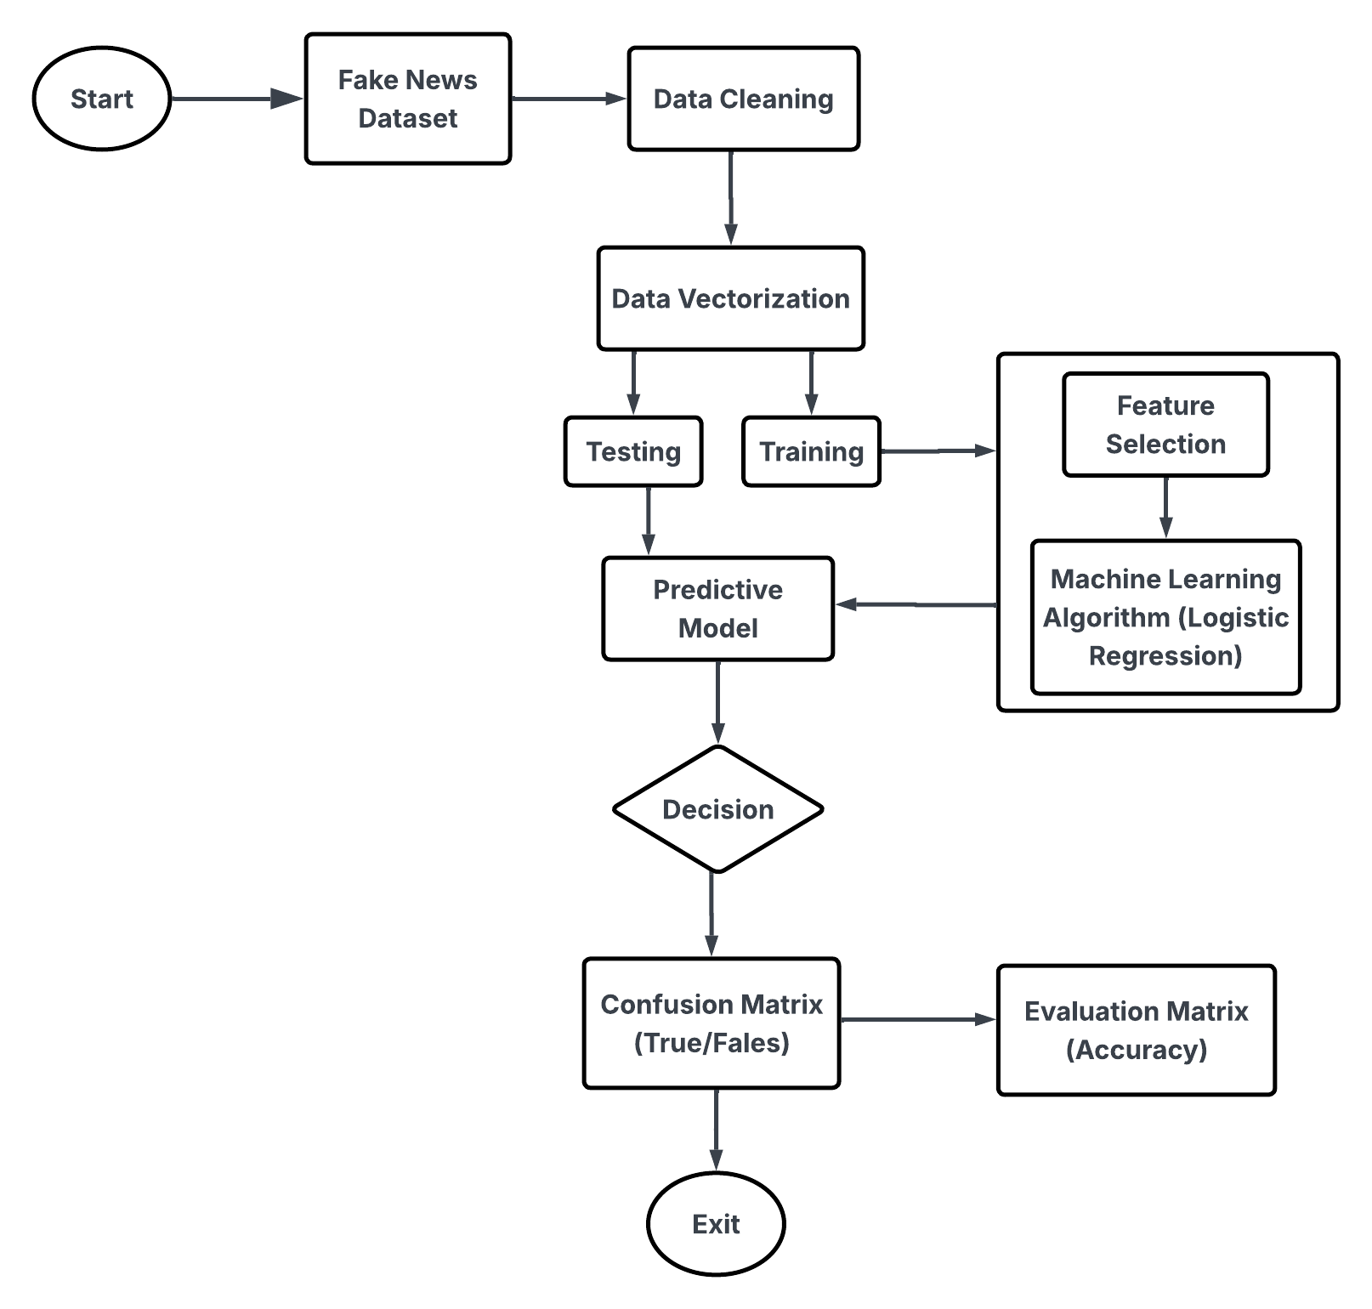

SYSTEM ANALYSIS
Problem Statement:
The growing volume of online misinformation necessitates an automated approach for fake news detection. Current manual fact-checking methods are insufficient due to:
- High volume of digital content, making manual verification impractical.
- Bias in human judgment, leading to inconsistencies in classification.
- Lack of real-time verification, allowing misinformation to spread before being flagged.
- Impact on public trust, influencing elections, healthcare decisions, and public perception.
This project aims to develop a machine learning-based model that automatically classifies news articles as real or fake based on text content analysis.
System Requirements:
Hardware Requirements:
• Processor: Intel i5 or higher (for faster ML training)
• RAM: Minimum 4GB (8GB recommended)
• Storage: 20 GB free (for dataset and libraries)
• Internet: For downloading datasets/libraries
Software Requirement:
OS: Windows / Linux
Language: Python 3.x
Libraries:
Pandas – data handling
NumPy – numerical computing
Scikit-learn – machine learning
NLTK – natural language processing
IDE: Jupyter Notebook / VS Code / Colab
Dataset: Kaggle's Fake and Real News Dataset

SYSTEM IMPLEMENTATION
Overview :
• Pre-processing: Using NLTK for tokenization, stopwords, stemming
• Vectorization: Using TfidfVectorizer from sklearn
• Modeling: LogisticRegression() from sklearn.linear_model
• Evaluation: Accuracy score
Dataset Handling :
• Read CSV from Kaggle
• Label encoding for 'real' and 'fake'
• Handle missing values, duplicates
Evaluation Output :
• Accuracy Score: 98%
• Confusion Matrix: Shows true vs false predictions
Testing & debugging :
• Manually tested by entering real/fake news headlines
• Cross-validation to check model robustness

Snapshots:

CONCLUSION
The fake news detection system effectively classifies news as real or fake using text classification techniques. The integration of NLP pre-processing and TF-IDF with a logistic regression classifier provides a reliable and interpretable solution.
Through evaluation metrics, the model demonstrates high accuracy, making it suitable for real-world deployment. Further improvements can be achieved by using larger datasets, multilingual support, or integrating deep learning models.

REFERANCE / BIOGRAPHY
- Zhou, Xinyi, and Reza Zafarani. "Fake News: A Survey of Research, Detection Methods, and Opportunities." (2018)
- Shu, Kai, et al. "Fake News Detection on Social Media: A Data Mining Perspective." (2017)
- Scikit-learn documentation: https://scikit-learn.org
- Kaggle datasets: https://www.kaggle.com
- NLTK documentation: https://www.nltk.org

